A3 Annotations:

1. 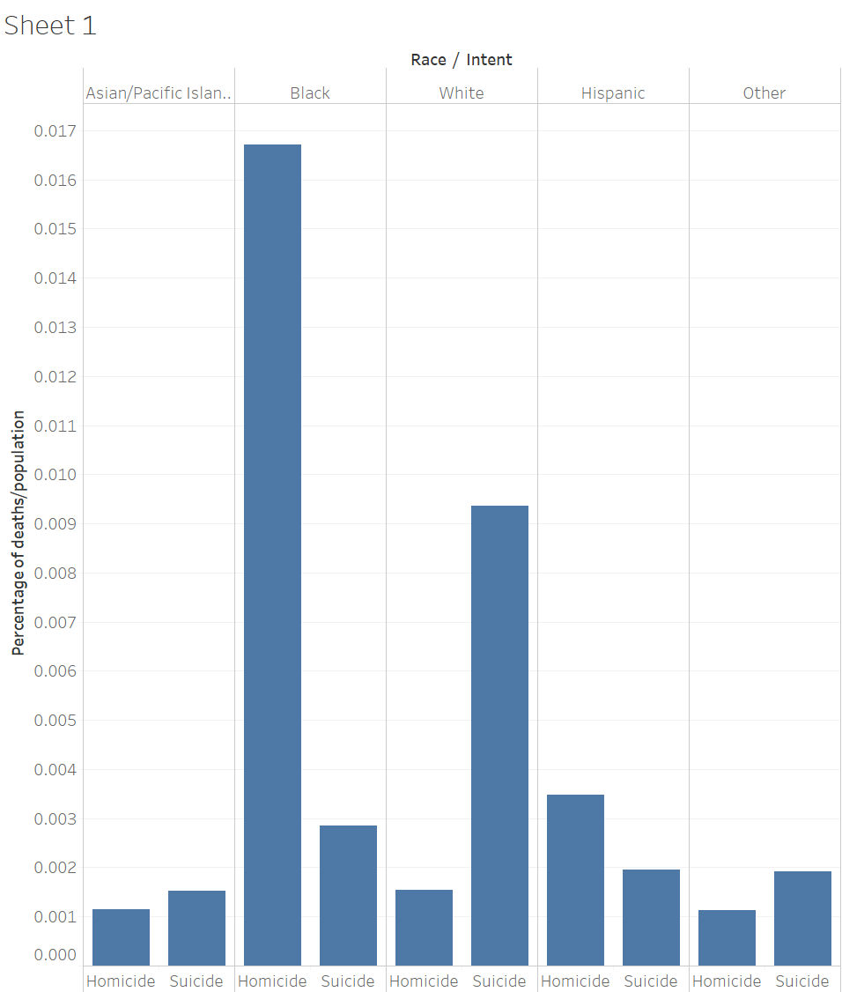
   1. Black people are substantially more likely to be killed by guns in homicides than any other race. This most likely stems from the disproportionate number of black people involved with law enforcement.
   2. While White people are seen to die by guns in suicide cases more than any other race. This most likely stems from white people being more likely to own guns and thus having access to them when confronted with suicidal tendencies.
2. 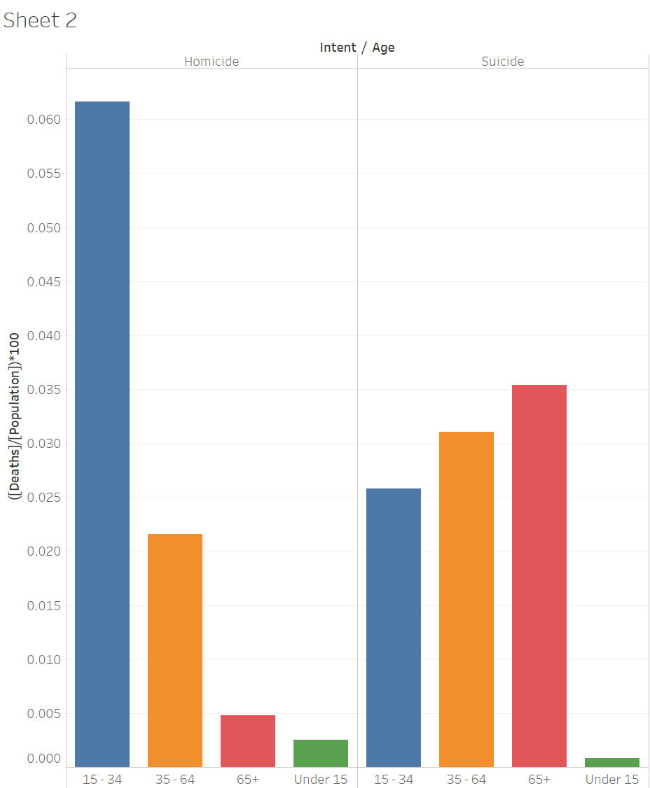
   1. Homicide is seen overwhelmingly in the teen to young-adult age group. Which makes sense given that most police violence is directed towards younger people and crime is also lessened with age.
   2. Suicide is reversed such that it rises with age. Which comes from as people age they are more likely to own guns and are more likely to have mental deterioration leading to suicidal tendencies.
3. 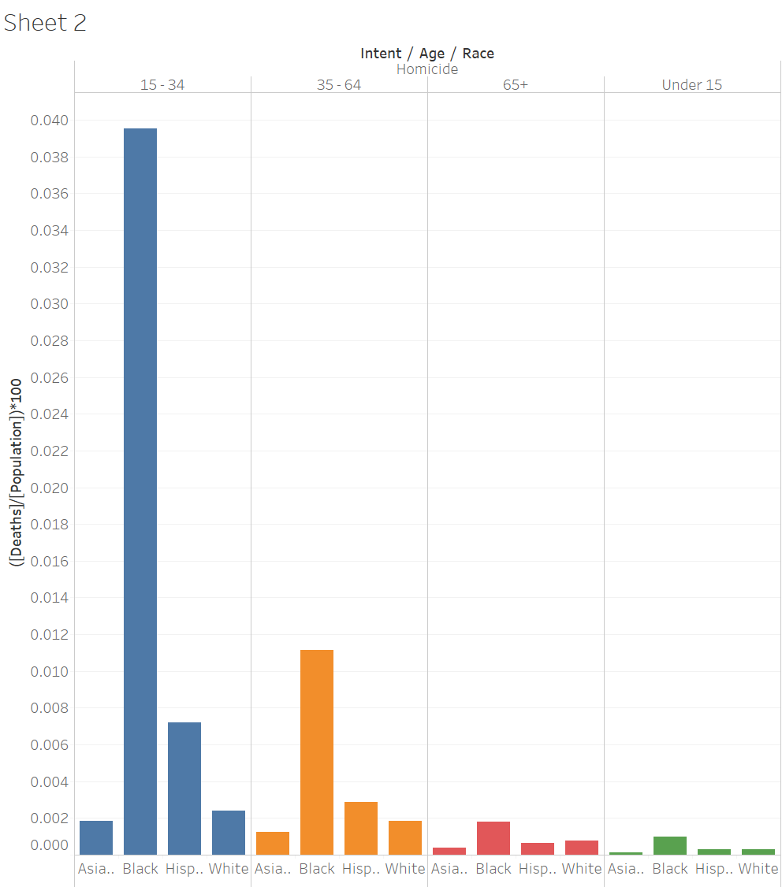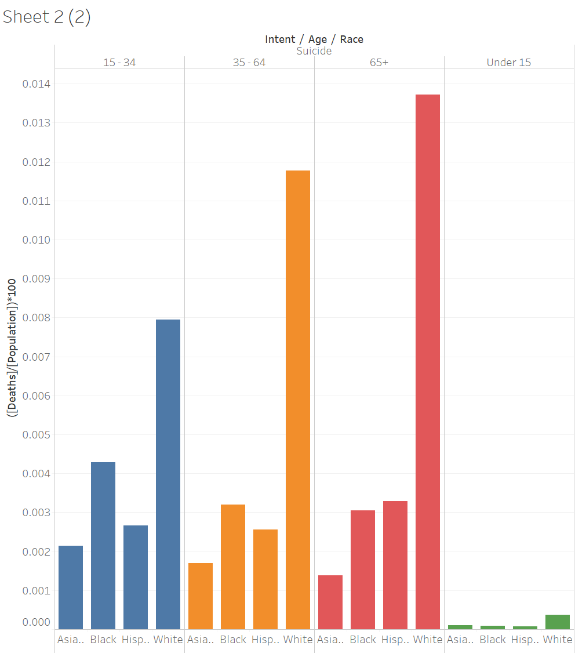
   1. When we split the deaths on not only intent and age, but also on race, we see that black people are always leading the homicide deaths for all age groups. Similarly, white people have the highest rate of suicide for all age groups.
   2. And we see that most of those teen to young-adult homicide deaths are disproportionately black.